**Web stack Development LAB-5**

**Domain: EV TRIP PLANNER**

**OBJECTIVE**

The objective of this lab activity is to understand how to work with XML data structures, validate XML using XSD schemas, and transform XML data into a user-friendly HTML format using XSLT. By the end of this activity, you will have hands-on experience with creating, validating, and transforming XML files.

**SUMMARY**

In this lab activity, I explored the use of XML (Extensible Markup Language) and related technologies to manage and display data in a structured and user-friendly manner. The project involved creating an XML (ev1.xml) file to represent an EV trip, including details about the vehicle, charging stations, hotels, and user feedback.

I then developed an XSD (ev1.xsd) to validate the structure and content of the XML file, ensuring that the data conforms to specific rules and constraints. This step was crucial for maintaining data integrity and consistency.

Finally, used XSLT (transform.xsl) to transform the XML data into an HTML document. The XSLT stylesheet applied styles and formatting to make the data visually appealing and easy to read in a web browser.

**XSD VALIDATION**

The purpose of an XSD (XML Schema Definition) is to define the structure, content, and data types of an XML document. It ensures that the XML data is correctly formatted and follows specific rules, acting as a blueprint for how the XML document should be organized.

This XSD defines the structure of an XML document for an Electric Vehicle (EV) domain. It includes:

ev: The root element.

vehicle: Contains model (string), range (positive integer), and battery_capacity (positive integer).

charging_station: Includes name, location, and charger_type (all strings).

hotel: Contains name and location (strings), and rating (decimal).

feedback: Has comment (string), rating (positive integer), and feedback_type (string).

Restrictions were given:

* Rating for hotels can be from 1 to 5
* Range from 1to 1000
* Battery capacity from 1 to 200
* Charger type can be ac, dc fast charger or level 2 charger

Errors like typos were occurred like misspelling occurred, accidentally.

Xsd validation is tested by giving the value for the battery capacity as ‘300’ which actually restricted to’200’ by the xsd and it was working.

**XSL STYLING**

The purpose of XSL (Extensible Stylesheet Language) is to transform and style XML documents. It allows you to define how the data in an XML document is displayed or presented, either by converting it into different formats (like HTML, PDF, or another XML structure) or by applying specific formatting and styling rules.

In this xml file ‘transform.xsl ‘is used to the contents in the ‘ev1.xml’to user friendly and more appealing style. Different entities are listed in different tables for better understandability

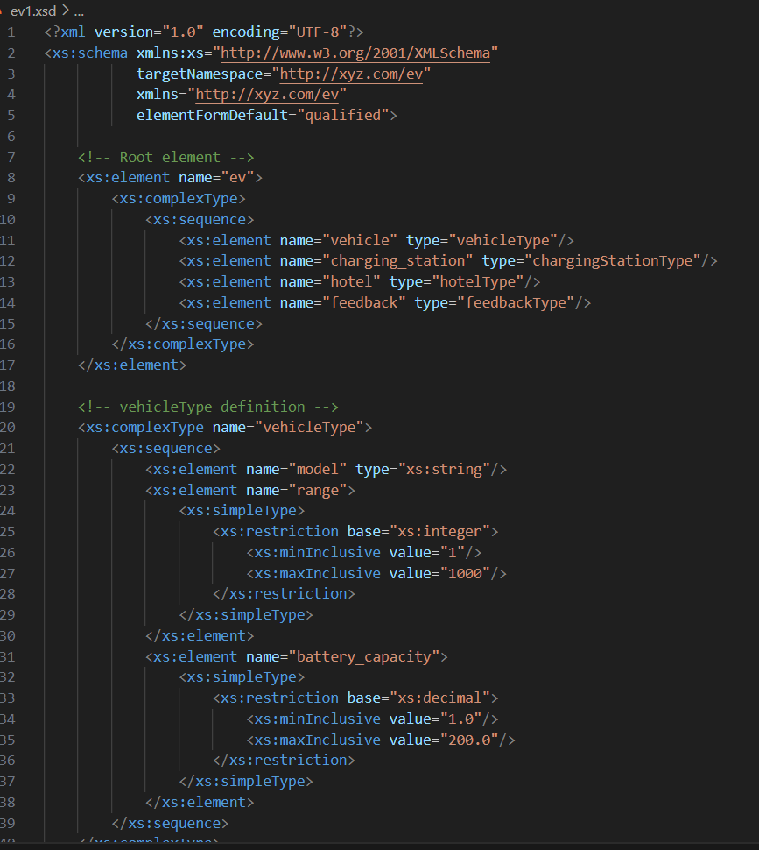Ev1.xsd

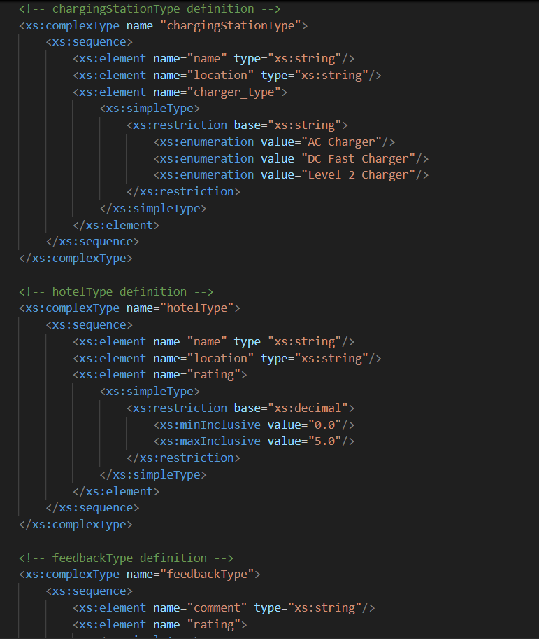

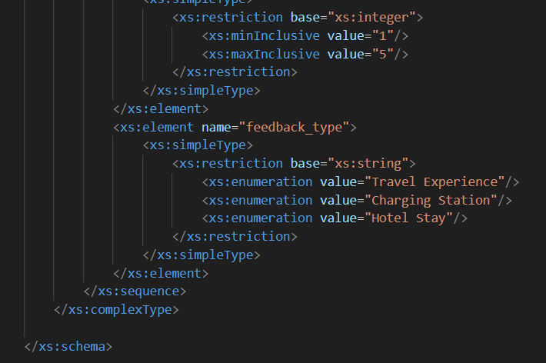

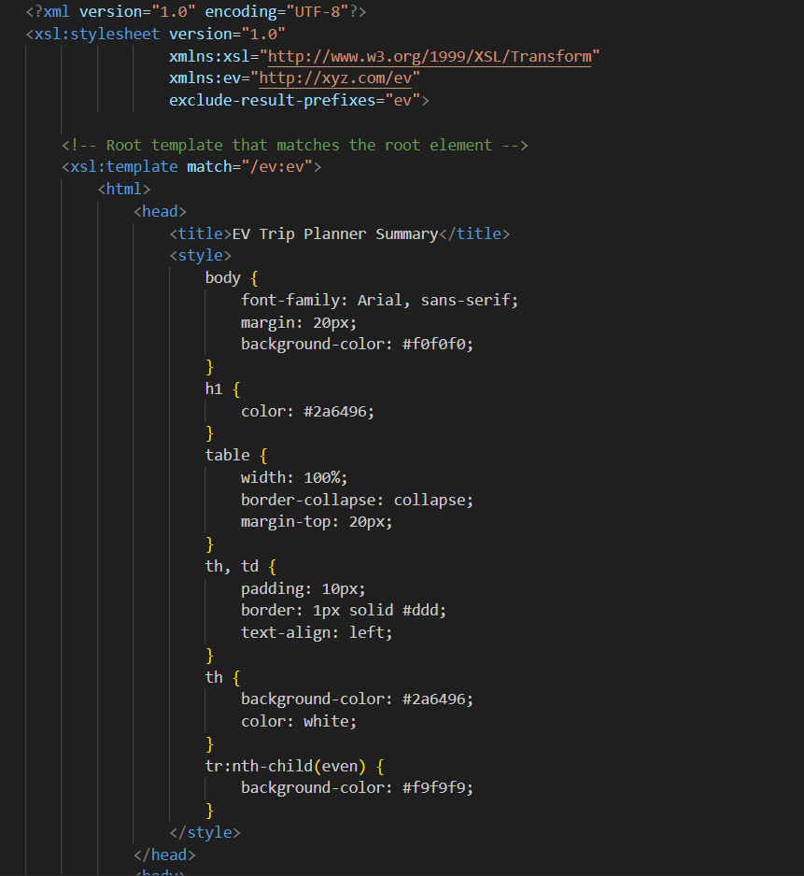Transform.xsl

